URGENT DIPLOMATIC & CONSULAR NOTICE TO THE HIGH COMMISSIONER OF SOUTH AFRICA IN PAKISTAN
Notice of Transnational Armed Extortion, Cybercrime & Request for Immigration V-Listing against Hafiz Abdul Rehman

TO:
HIS EXCELLENCY, THE HIGH COMMISSIONER OF THE REPUBLIC OF SOUTH AFRICA TO PAKISTAN
SOUTH AFRICAN HIGH COMMISSION, DIPLOMATIC ENCLAVE, SECTOR G-5, ISLAMABAD
ATTENTION: FIRST SECRETARY (IMMIGRATION & CONSULAR AFFAIRS) & DIRCO LIAISON

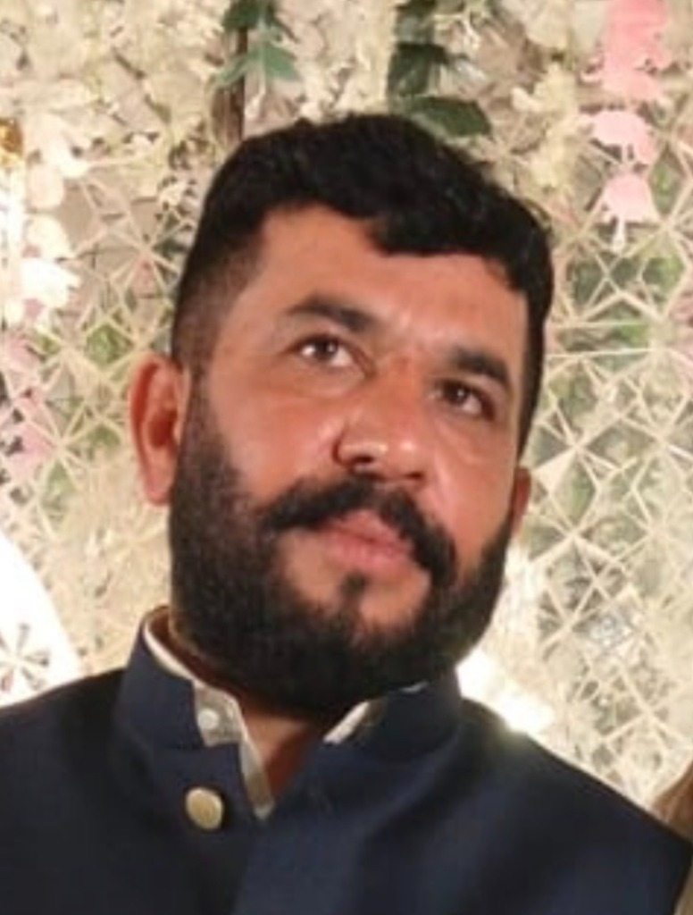  Accused: Hafiz Abdul Rehman  (South Africa) | ACCUSED PROFILE & IDENTIFICATION:  • Full Name: HAFIZ ABDUL REHMAN  • South African Phone / WhatsApp: +27 84 663 7272 (084 663 7272)  • South African Enterprise: Albaraka Protection Services  • Origin & Ties: District Sheikhupura / Gujranwala, Pakistan  • Status: Wanted in Pakistan under Section 7 ATA / 386 PPC (E-Tag: SDS-05/09/2026-5171)  • Extorted Amount: Meezan Bank Cheque PKR 10,000,000.00 (Chq: C-86770295)

SUBJECT: DIPLOMATIC REQUEST FOR IMMIGRATION STOP-LISTING (V-LIST), VISA STATUS AUDIT & TRANSMISSION TO DHA / SAPS HAWKS REGARDING HAFIZ ABDUL REHMAN (+27846637272 | ALBARAKA PROTECTION SERVICES, SOUTH AFRICA) WANTED FOR 24-HR HOSTAGE TAKING & EXTORTION OF PKR 10,000,000.00.

1. EXECUTIVE DIPLOMATIC BRIEFING
We respectfully bring to the urgent attention of the High Commission of the Republic of South Africa that a Pakistani-origin individual, HAFIZ ABDUL REHMAN, residing in South Africa and operating an enterprise known as 'Albaraka Protection Services', is orchestrating transnational violent crime and armed extortion from South African soil using South African cellular line +27 84 663 7272.
2. TRANSNATIONAL CRIME & OFFICIAL POLICE RECORD
On 03-04 September 2026, the subject directed an armed siege at Al-Barakah Marquee complex, Sheikhupura, detaining two Pakistani citizens at gunpoint for 24 hours and extorting a PKR 10,000,000.00 Meezan Bank cheque under threat of execution. The matter is formally recorded with Punjab Police under E-Tag SDS-05/09/2026-5171 under Anti-Terrorism Act Section 7 and 386 PPC.
3. REQUESTS TO THE SOUTH AFRICAN DIPLOMATIC MISSION
We formally request His Excellency the High Commissioner to:
1. Diplomatic Cable: Transmit an urgent diplomatic advisory to DIRCO (Department of International Relations and Cooperation) and Department of Home Affairs (DHA) in Pretoria.
2. Visa & Passport Flagging: Request Home Affairs to immediately place Hafiz Abdul Rehman on the National V-List (Stop-List) to prevent evasion and facilitate consular detention.
3. Coordinate with FIA INTERPOL: Facilitate bilateral communication between Pakistan FIA and SAPS Hawks NCB Pretoria.

VERIFICATION:
I, Usman Farooq (CNIC: 35201-1478637-5), do hereby solemnly affirm and declare on oath that the contents of this petition are true and correct to the best of my knowledge, and all electronic evidence, voice transcripts, and police records are verifiable before any competent legal authority.
RESPECTFULLY SUBMITTED BY:
_____________________________________
USMAN FAROOQ (Applicant / Aggrieved Party)
Director, Fusion Developers
Phone / WhatsApp: +92 332 2227426 / +92 308 4025252
Dated: 26 September 2026

