FORMAL CRIMINAL COMPLAINT UNDER CYBERCRIME ACT 19 OF 2020 & PREVENTION OF ORGANISED CRIME ACT 121 OF 1998 (POCA)
Transnational Cyber-Extortion, Armed Hostage Racketeering & Terror Financing via SA Telecom Line (+27846637272)

TO:
THE NATIONAL HEAD, DIRECTORATE FOR PRIORITY CRIME INVESTIGATION (DPCI - THE HAWKS), REPUBLIC OF SOUTH AFRICA
THE NATIONAL COMMISSIONER, SOUTH AFRICAN POLICE SERVICE (SAPS), PRETORIA
THE HEAD OF INTERPOL NATIONAL CENTRAL BUREAU (NCB), PRETORIA, SOUTH AFRICA

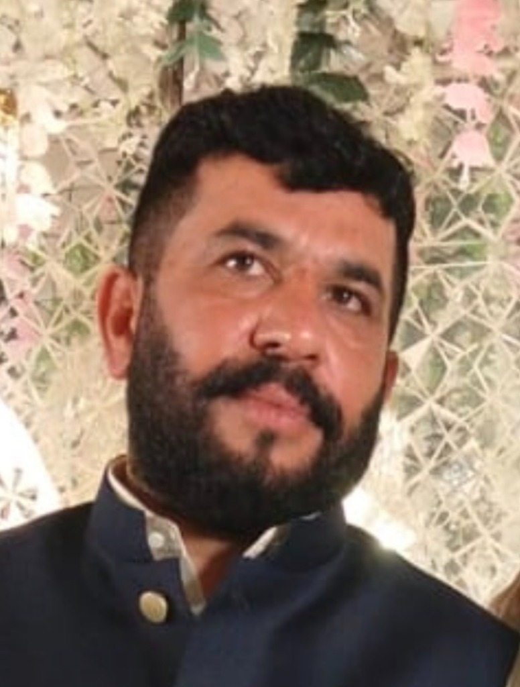  Accused: Hafiz Abdul Rehman  (South Africa) | ACCUSED PROFILE & IDENTIFICATION:  • Full Name: HAFIZ ABDUL REHMAN  • South African Phone / WhatsApp: +27 84 663 7272 (084 663 7272)  • South African Enterprise: Albaraka Protection Services  • Origin & Ties: District Sheikhupura / Gujranwala, Pakistan  • Status: Wanted in Pakistan under Section 7 ATA / 386 PPC (E-Tag: SDS-05/09/2026-5171)  • Extorted Amount: Meezan Bank Cheque PKR 10,000,000.00 (Chq: C-86770295)

SUBJECT: CRIMINAL COMPLAINT UNDER SECTION 14 OF CYBERCRIME ACT (ACT 19 OF 2020), SECTIONS 2 & 4 OF POCA (ACT 121 OF 1998) AGAINST HAFIZ ABDUL REHMAN (+27846637272 | ALBARAKA PROTECTION SERVICES) FOR TRANSNATIONAL CYBER-EXTORTION, RACKETEERING, 24-HR ARMED KIDNAPPING & MONEY LAUNDERING OF PKR 10,000,000.00.

1. STATEMENT OF JURISDICTION (CYBERCRIME ACT 19 OF 2020)
Under Section 14 and Section 24 of the South African Cybercrime Act (Act 19 of 2020), South African Courts and SAPS/DPCI have extraterritorial jurisdiction over cyber-extortion, electronic threats, and cyber-enabled racketeering where the electronic communications originate from within South Africa or utilize South African mobile/telecommunication networks. The subject Hafiz Abdul Rehman originated direct extortion calls and digital coercion from South African telecom number +27 84 663 7272 into Pakistan.
2. FACTUAL MATRIX & TRANSNATIONAL SYNDICATE STRUCTURE
• Command & Control from South Africa: The accused Hafiz Abdul Rehman acts as the international kingpin of an armed extortion ring in Sheikhupura, Pakistan. While physically in South Africa, he directs local armed enforcers (Sohail Gondal, Akbar Gondal).
• 24-Hour Confinement: On 03-04 September 2026, applicant was detained at gunpoint inside Al-Barakah Marquee complex.
• 4:00 AM Extortion Demand via +27846637272: The accused directly communicated the extortion demand of PKR 10,000,000.00, threatening summary execution unless Meezan Bank Cheque No. C-86770295 was signed and handed over.
• Police Rescue: Punjab Police Elite vehicle ATA-130 and ASI (0322-4761984) rescued the applicant after the extortion was committed (Police E-Tag: SDS-05/09/2026-5171).
3. APPLICATION OF PREVENTION OF ORGANISED CRIME ACT (POCA 121 OF 1998)
The activities of Hafiz Abdul Rehman constitute 'Racketeering Activity' and 'Pattern of Racketeering Activity' under Chapter 2 of POCA. The extortion proceeds are channeled through cross-border banking accounts and offshore entities including 'Albaraka Protection Services', invoking mandatory financial asset forfeiture and anti-money laundering investigations under South African law.
4. PRAYERS FOR CRIMINAL ACTION
The Applicant requests that the DPCI (The Hawks) and SAPS:
1. Register Criminal Docket: Register a formal criminal investigation docket against Hafiz Abdul Rehman under Section 14 of Cybercrime Act 2020 and POCA 1998.
2. RICA Intercept & Subpoena: Subpoena call records, geolocation, and IMEI history for South African mobile number +27 84 663 7272 from South African cellular providers (Vodacom/MTN/Cell C/Telkom).
3. Coordinate with INTERPOL NCB Islamabad: Interface with FIA Counter-Terrorism Wing & INTERPOL Islamabad for Mutual Legal Assistance (MLA) and issuance of Red Notice.
4. Asset Freezing: Coordinate with Asset Forfeiture Unit (AFU) to freeze all South African bank accounts and business assets associated with Hafiz Abdul Rehman and 'Albaraka Protection Services'.

VERIFICATION:
I, Usman Farooq (CNIC: 35201-1478637-5), do hereby solemnly affirm and declare on oath that the contents of this petition are true and correct to the best of my knowledge, and all electronic evidence, voice transcripts, and police records are verifiable before any competent legal authority.
RESPECTFULLY SUBMITTED BY:
_____________________________________
USMAN FAROOQ (Applicant / Aggrieved Party)
Director, Fusion Developers
Phone / WhatsApp: +92 332 2227426 / +92 308 4025252
Dated: 26 September 2026

