FORMAL PETITION UNDER RICA ACT (ACT 70 OF 2002) & CYBERCRIME ACT 2020
Urgent Preservation of Digital Telemetry, CDR Records, Cell-Tower Geolocation & SIM De-registration (+27846637272)

TO:
THE CHAIRPERSON, INDEPENDENT COMMUNICATIONS AUTHORITY OF SOUTH AFRICA (ICASA), SANDTON, JOHANNESBURG
THE HEAD OF RICA COMPLIANCE & LAW ENFORCEMENT LIAISON, CELL C / MTN / VODACOM SOUTH AFRICA
COPY TO: SAPS DPCI HAWKS (CYBERCRIME DIVISION), PRETORIA

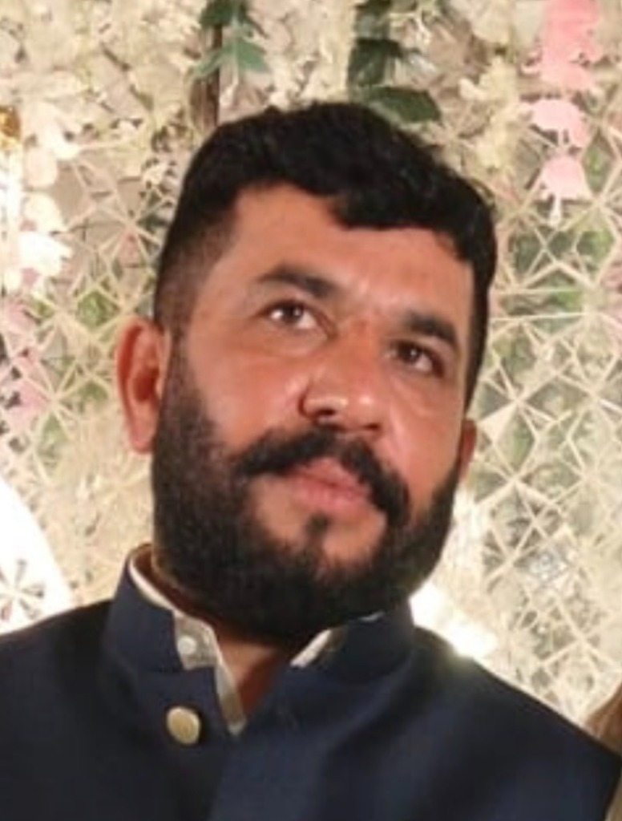  Accused: Hafiz Abdul Rehman  (South Africa) | ACCUSED PROFILE & TRANSNATIONAL ENTERPRISE:  • Full Name: HAFIZ ABDUL REHMAN  • South African Phone / WhatsApp: +27 84 663 7272 (084 663 7272)  • South African Enterprise: Albaraka Protection Services  • Origin & Links: District Sheikhupura / Gujranwala, Pakistan  • Police Record: E-Tag SDS-05/09/2026-5171 (Section 7 ATA 1997 / 386 PPC)  • Extorted Instrument: Meezan Bank Cheque PKR 10,000,000.00 (Chq: C-86770295)

SUBJECT: APPLICATION UNDER SECTION 205 OF RICA (ACT 70 OF 2002) & SECTION 14 OF CYBERCRIME ACT 19 OF 2020 FOR IMMEDIATE PRESERVATION OF CALL DETAIL RECORDS (CDR), CELL TOWER GEOLOCATION, IMEI METADATA AND REGULATORY SUSPENSION OF CELLULAR NUMBER +27 84 663 7272.

1. STATUTORY JURISDICTION UNDER RICA (ACT 70 OF 2002)
Under Section 205 and Chapter 5 of the Regulation of Interception of Communications and Provision of Communication-Related Information Act (Act 70 of 2002), telecommunication service providers are obligated to retain communication-related information and provide subscriber telemetry, call records, and geolocation under lawful court and police investigation directives.
2. TELECOMMUNICATION ABUSE IN TRANSNATIONAL ARMED EXTORTION
The South African mobile line +27 84 663 7272 was directly utilized by the subscriber Hafiz Abdul Rehman at 4:00 AM on 04 September 2026 to communicate armed extortion threats into Pakistan, coercing the signing of a PKR 10,000,000.00 cheque while victims were held hostage at gunpoint. This represents direct weaponization of South African cellular infrastructure for extraterritorial violent crimes.
3. PRAYERS FOR TELECOM EVIDENCE PRESERVATION
1. Immediate 90-Day Evidence Preservation: Issue an emergency preservation notice to the carrier to lock and prevent deletion of all CDR records, tower triangulation data, IMEI logs, and SMS metadata for +27 84 663 7272.
2. Subscriber Verification: Disclose the registered name, ID/Passport number, and physical RICA address on record for MSISDN +27 84 663 7272.
3. Carrier Network Blacklisting: Suspend the SIM card and blacklist the handset IMEI on the Central Equipment Identity Register (CEIR).

VERIFICATION:
I, Usman Farooq (CNIC: 35201-1478637-5), do hereby solemnly affirm and declare on oath that the contents of this petition are true and correct to the best of my knowledge, and all electronic evidence, voice transcripts, and police records are verifiable before any competent legal authority.
RESPECTFULLY SUBMITTED BY:
_____________________________________
USMAN FAROOQ (Applicant / Aggrieved Party)
Director, Fusion Developers
Phone / WhatsApp: +92 332 2227426 / +92 308 4025252
Dated: 26 September 2026

