FORMAL PETITION UNDER PRIVATE SECURITY INDUSTRY REGULATION ACT (ACT 56 OF 2001)
Urgent Compliance Audit, License Cancellation & Criminal Investigation into 'Albaraka Protection Services' and Hafiz Abdul Rehman

TO:
THE CHIEF EXECUTIVE OFFICER & HEAD OF COMPLIANCE, PRIVATE SECURITY INDUSTRY REGULATORY AUTHORITY (PSiRA), CENTURION, SOUTH AFRICA
THE SENIOR MANAGER: LAW ENFORCEMENT & INVESTIGATIONS, PSiRA, REPUBLIC OF SOUTH AFRICA

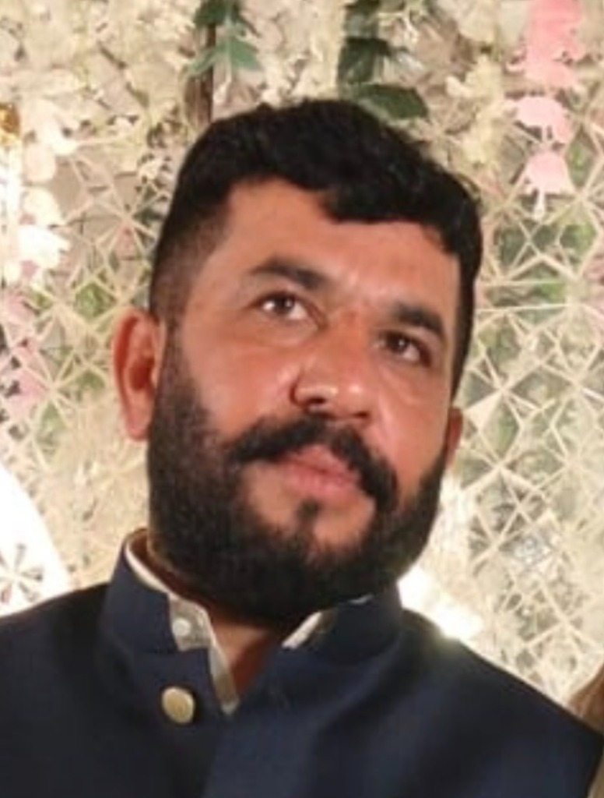  Accused: Hafiz Abdul Rehman  (South Africa) | ACCUSED PROFILE & IDENTIFICATION:  • Full Name: HAFIZ ABDUL REHMAN  • South African Phone / WhatsApp: +27 84 663 7272 (084 663 7272)  • South African Enterprise: Albaraka Protection Services  • Origin & Ties: District Sheikhupura / Gujranwala, Pakistan  • Status: Wanted in Pakistan under Section 7 ATA / 386 PPC (E-Tag: SDS-05/09/2026-5171)  • Extorted Amount: Meezan Bank Cheque PKR 10,000,000.00 (Chq: C-86770295)

SUBJECT: PETITION UNDER SECTIONS 20, 26, 28 & 38 OF THE PRIVATE SECURITY INDUSTRY REGULATION ACT (ACT 56 OF 2001) TO AUDIT, DEREGISTER, AND PROSECUTE 'ALBARAKA PROTECTION SERVICES' AND ITS PRINCIPAL HAFIZ ABDUL REHMAN (+27846637272) FOR ILLEGAL SECURITY SERVICES, USE OF PRIVATE SECURITY COVER FOR ARMED EXTORTION & MONEY LAUNDERING.

1. STATUTORY MANDATE OF PSiRA (ACT 56 OF 2001)
Under Section 20 and Section 28 of the Private Security Industry Regulation Act (Act 56 of 2001), no person may render a security service or operate a security business in South Africa unless registered with PSiRA, and registered service providers must strictly comply with the Code of Conduct for Security Service Providers (2003). Crucially, individuals with criminal convictions or involvement in organized crime, violence, or extortion are statutorily disqualified from holding a security license.
2. MISUSE OF SECURITY INDUSTRY FRONT FOR TRANSNATIONAL CRIMES
Hafiz Abdul Rehman is actively utilizing his entity 'Albaraka Protection Services' in South Africa as a legitimate veneer to shield himself while operating an armed extortion, illegal confinement, and kidnapping syndicate across borders. On 03-04 September 2026, he directed an armed siege in Pakistan that extorted PKR 10,000,000.00 (Police E-Tag: SDS-05/09/2026-5171), demonstrating extreme criminal conduct wholly incompatible with the fit-and-proper person requirements of South Africa's security industry.
3. PRAYERS FOR PSiRA LAW ENFORCEMENT
1. Forensic Compliance Audit: Conduct an immediate unannounced audit of 'Albaraka Protection Services' to verify PSiRA business registration number, physical operational address in SA, firearms permits, and security personnel vetting.
2. Immediate Suspension & Deregistration: Exercise statutory powers under Section 26 of Act 56 of 2001 to suspend and cancel any PSiRA registration or security provider license issued to Hafiz Abdul Rehman or 'Albaraka Protection Services'.
3. Criminal Referral to SAPS: Refer the entity and its principal to SAPS / The Hawks for prosecution under Section 38 of the PSiRA Act for rendering unlawful security services and criminal conduct.
4. Blacklist from SA Security Industry: Permanently bar Hafiz Abdul Rehman from ever holding any directorship, management position, or security accreditation in the Republic of South Africa.

VERIFICATION:
I, Usman Farooq (CNIC: 35201-1478637-5), do hereby solemnly affirm and declare on oath that the contents of this petition are true and correct to the best of my knowledge, and all electronic evidence, voice transcripts, and police records are verifiable before any competent legal authority.
RESPECTFULLY SUBMITTED BY:
_____________________________________
USMAN FAROOQ (Applicant / Aggrieved Party)
Director, Fusion Developers
Phone / WhatsApp: +92 332 2227426 / +92 308 4025252
Dated: 26 September 2026

