FORMAL PETITION FOR DECLARATION AS PROHIBITED PERSON (SECTION 29) & UNDESIRABLE PERSON (SECTION 30) OF THE IMMIGRATION ACT 13 OF 2002
Urgent V-Listing, Visa Revocation, Business Permit Cancellation & Port-of-Entry Flagging against Transnational Extortion Kingpin

TO:
THE DIRECTOR-GENERAL, DEPARTMENT OF HOME AFFAIRS (DHA), REPUBLIC OF SOUTH AFRICA
THE HEAD OF IMMIGRATION SERVICES & COUNTER-CORRUPTION INSPECTORATE, PRETORIA
COPY TO: THE HIGH COMMISSIONER, SOUTH AFRICAN HIGH COMMISSION, DIPLOMATIC ENCLAVE, ISLAMABAD

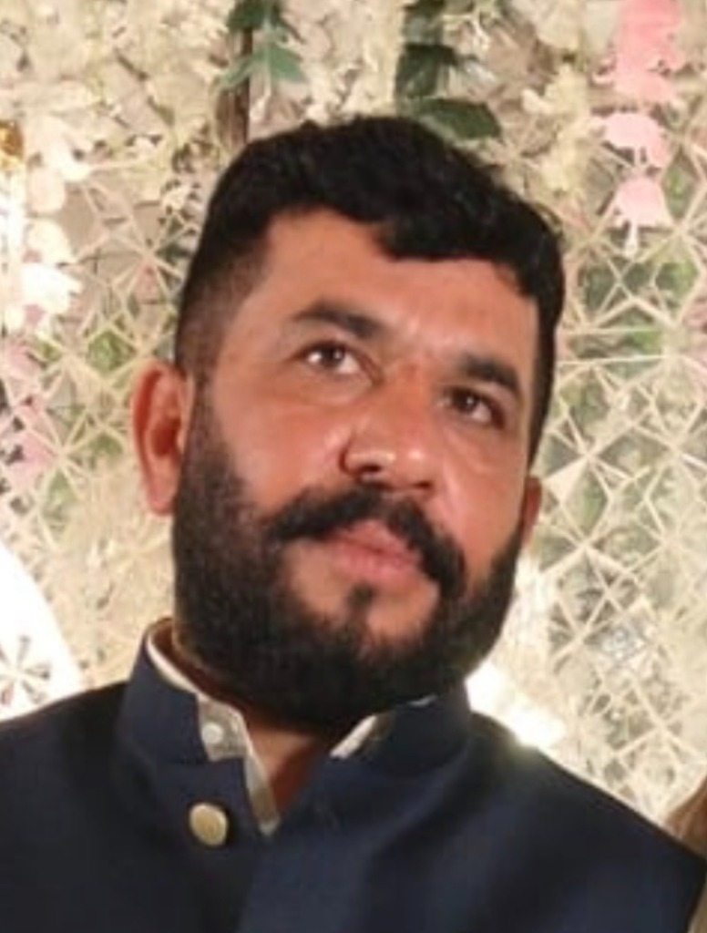  Accused: Hafiz Abdul Rehman  (South Africa) | ACCUSED PROFILE & IDENTIFICATION:  • Full Name: HAFIZ ABDUL REHMAN  • South African Phone / WhatsApp: +27 84 663 7272 (084 663 7272)  • South African Enterprise: Albaraka Protection Services  • Origin & Ties: District Sheikhupura / Gujranwala, Pakistan  • Status: Wanted in Pakistan under Section 7 ATA / 386 PPC (E-Tag: SDS-05/09/2026-5171)  • Extorted Amount: Meezan Bank Cheque PKR 10,000,000.00 (Chq: C-86770295)

SUBJECT: PETITION UNDER SECTIONS 29(1)(b), 29(1)(f), 30(1)(c) & 30(1)(g) OF THE SOUTH AFRICAN IMMIGRATION ACT (ACT 13 OF 2002) FOR IMMEDIATE DECLARATION OF HAFIZ ABDUL REHMAN AS A PROHIBITED & UNDESIRABLE PERSON, CANCELLATION OF ALL RESIDENCE / BUSINESS VISAS (ALBARAKA PROTECTION SERVICES), AND IMMEDIATE PLACEMENT ON THE NATIONAL IMMIGRATION STOP-LIST (V-LIST).

1. JURISDICTION & LEGAL STANDING UNDER ACT 13 OF 2002
This petition is formally submitted before the Department of Home Affairs under Sections 29 and 30 of the Immigration Act (Act No. 13 of 2002, as amended). The subject, HAFIZ ABDUL REHMAN, is currently residing, operating businesses ('Albaraka Protection Services'), and holding immigration status (Temporary/Permanent Residence or Business Visa) in the Republic of South Africa while actively masterminding and executing transnational armed extortion, violent hostage-taking, and cyber extortion targeting lawful businesses in Pakistan using his South African telecommunications connection (+27 84 663 7272).
2. CORE OFFENCES & GROUNDS FOR PROHIBITED STATUS (SECTION 29)
Under Section 29(1) of the Immigration Act, an individual is statutorily declared a PROHIBITED PERSON if they are a fugitive from justice, associated with organized crime syndicates, or pose a grave danger to public order and international security.
• Transnational Hostage Taking: On 03-04 September 2026, the accused orchestrated the 24-hour armed confinement of applicant Usman Farooq and witness Muhammad Saleem at Al-Barakah Marquee, Sheikhupura.
• Armed Extortion of Rs. 10,000,000.00: At 4:00 AM on 04 September 2026, the accused personally dialed from his South African mobile (+27 84 663 7272) to issue death threats, compelling the forced delivery of Meezan Bank Cheque No. C-86770295 (PKR 10M) via courier under armed duress.
• Police Registration: Formal complaint registered with Punjab Police under E-Tag SDS-05/09/2026-5171 (Thana Saddar Sheikhupura) under Section 7 of Anti-Terrorism Act 1997 and Section 386/365 PPC.
3. FRAUDULENT BUSINESS COVER — 'ALBARAKA PROTECTION SERVICES'
The accused purports to operate a security and protection entity in South Africa named 'Albaraka Protection Services'. The accused is utilizing this corporate front to shelter proceeds of transnational extortion, conceal his illicit activities, and maintain a facade of legitimate business presence in South Africa. The operation of armed extortion syndicates violates the core conditions of any business or work permit granted under South African law.
4. RELIEF & STATUTORY PRAYERS SOUGHT
The Applicant respectfully prays that the Department of Home Affairs, Republic of South Africa, immediately order:
1. Declaration under Section 29 & 30: Formally declare Hafiz Abdul Rehman a Prohibited and Undesirable Person in the Republic of South Africa.
2. National V-List Placement: Place the name, biometric profile, and passport details of Hafiz Abdul Rehman on the South African National Immigration Stop-List (V-List) across all airports and border posts (OR Tambo, Cape Town, King Shaka, Beitbridge).
3. Cancellation of Active Visas: Immediately revoke, cancel, and declare null and void any Temporary Residence Visa, Business Visa, Work Permit, or Permanent Residence status issued to him or his entity 'Albaraka Protection Services'.
4. Deportation / Port-of-Entry Arrest: Issue a warrant of deportation under Section 34 of the Immigration Act and coordinate with INTERPOL NCB Pretoria for his extradition to Pakistan.

VERIFICATION:
I, Usman Farooq (CNIC: 35201-1478637-5), do hereby solemnly affirm and declare on oath that the contents of this petition are true and correct to the best of my knowledge, and all electronic evidence, voice transcripts, and police records are verifiable before any competent legal authority.
RESPECTFULLY SUBMITTED BY:
_____________________________________
USMAN FAROOQ (Applicant / Aggrieved Party)
Director, Fusion Developers
Phone / WhatsApp: +92 332 2227426 / +92 308 4025252
Dated: 26 September 2026

